Installation of git
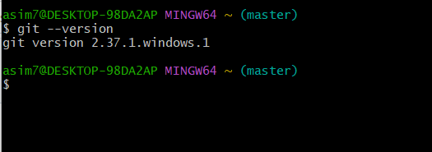

2) Create a repo in github with README.md and .ignore file.
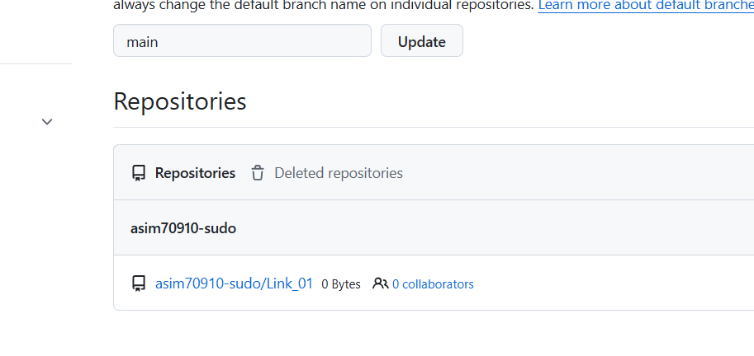
3) . Clone the created repo to local.

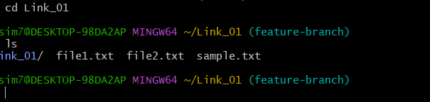

- Create two files in local repo.

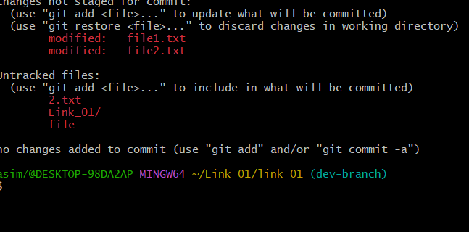

5) . Commit two files and push to central Repository.

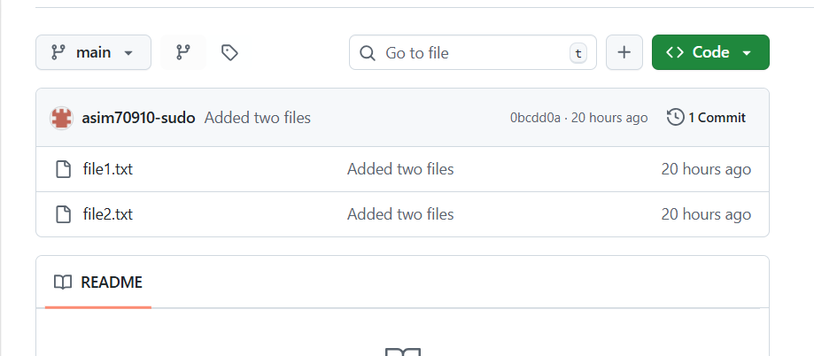
- .Create a branch in local and create a sample file and push to central.

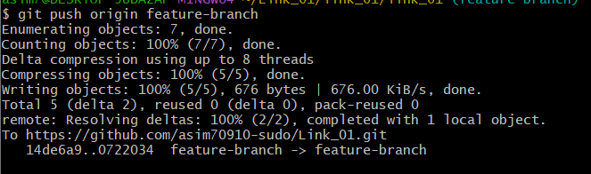

7). Create a branch in github and clone that to local.

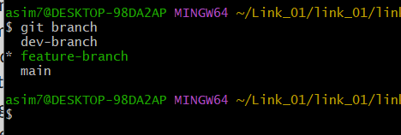

8). Merge the created branch with master in git local.

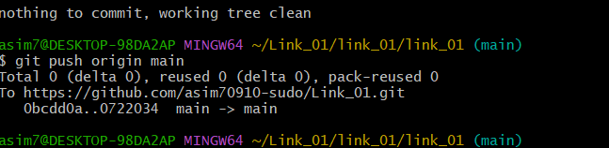

9). Merge the created branch with master in github by sending a pull request.

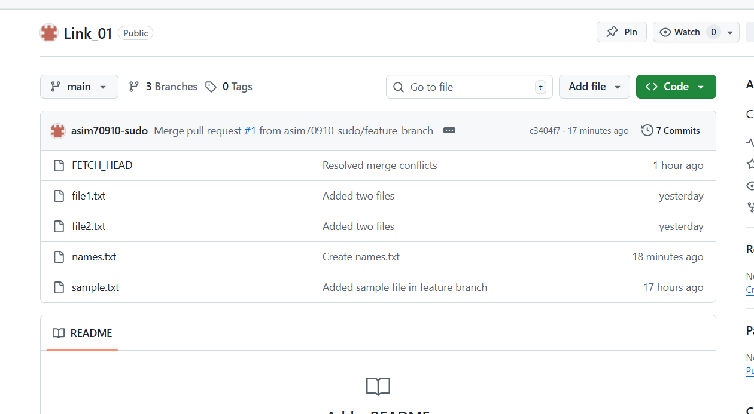
10). Create a file in local and send that to branch in github.

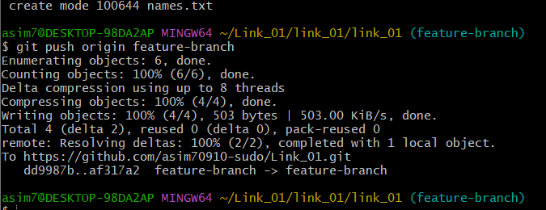

11). Clone only a branch from github to local.

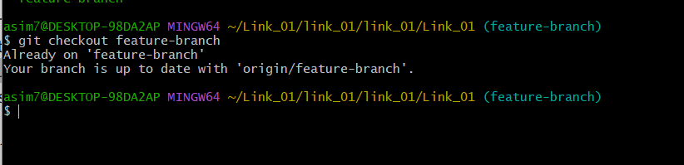

12). Create a file with all passwords and make that untrackable with git.

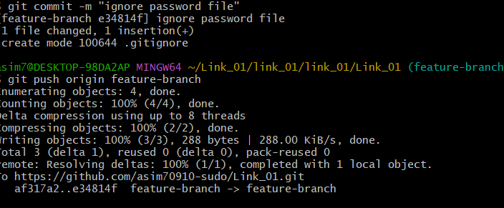

13). Make a commit and make that commit reset without savings changes.
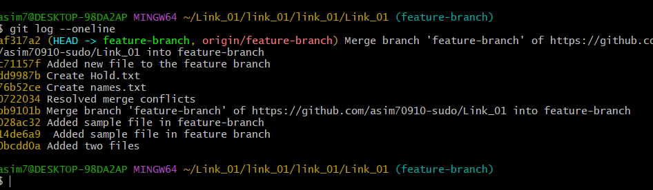

14). Revert a commited commit to the older version.

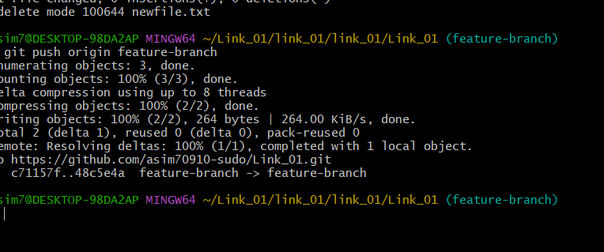

15). Push a file to stash without savings the changes and work on another file.

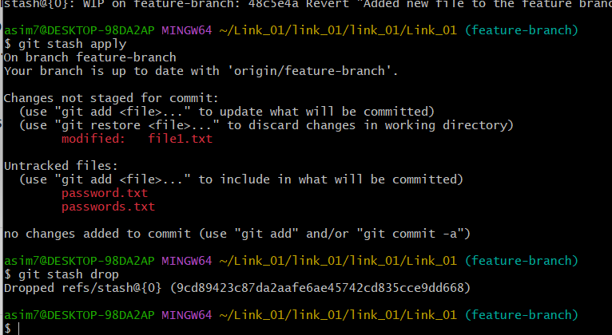

16). Undo the stash file and start working on that again
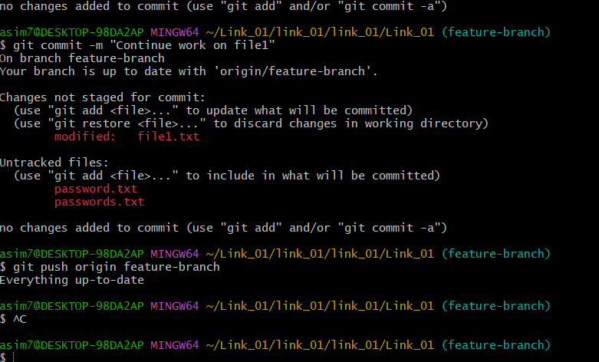

17). Generate a ssh-keygen and configure into github.
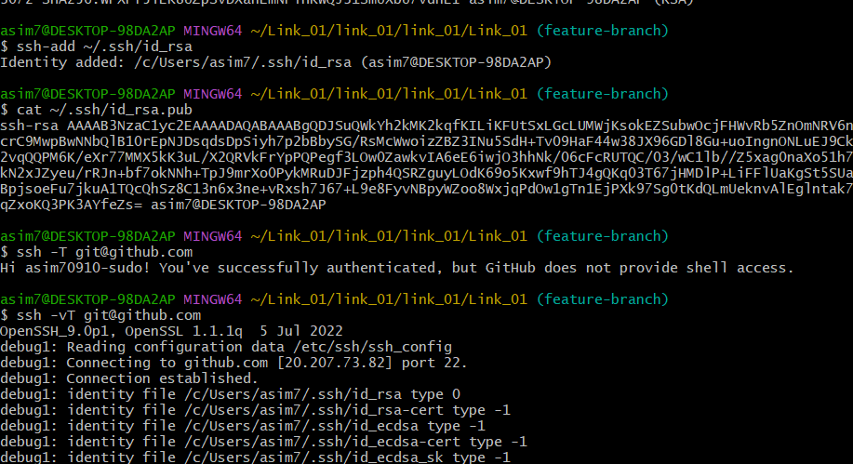

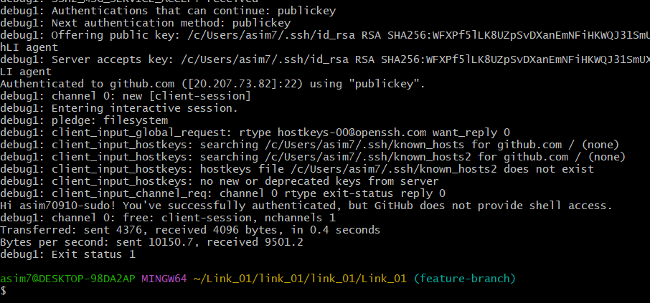

18) . Configure webhooks to github.
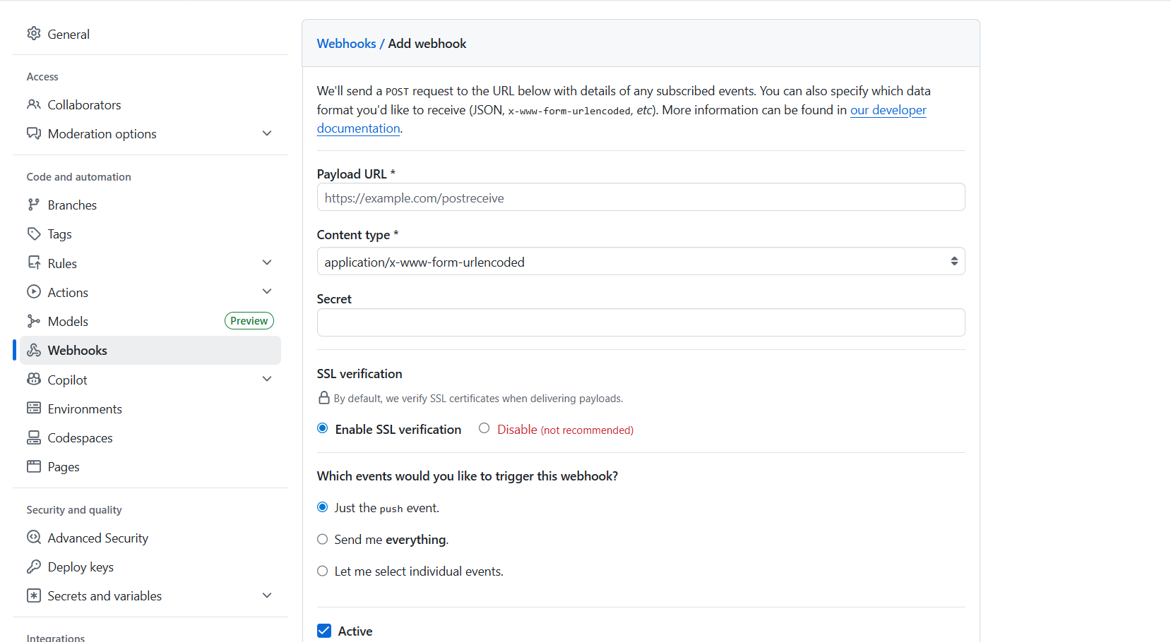

📁 What is .git?
👉 .git is a hidden folder created when you run:
git init
👉 It is the brain of your Git repository
✔ Stores all history
✔ Tracks commits
✔ Manages branches
✔ Handles staging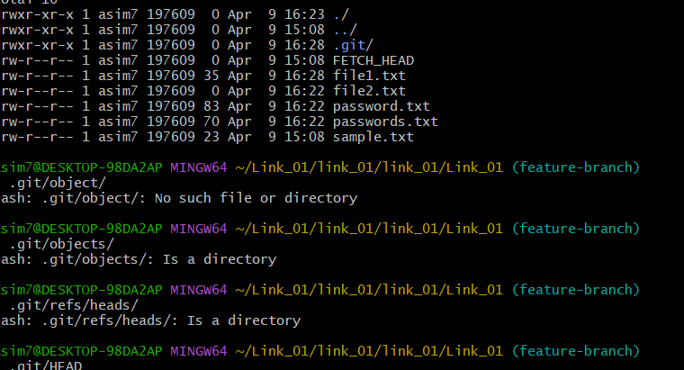

- git log
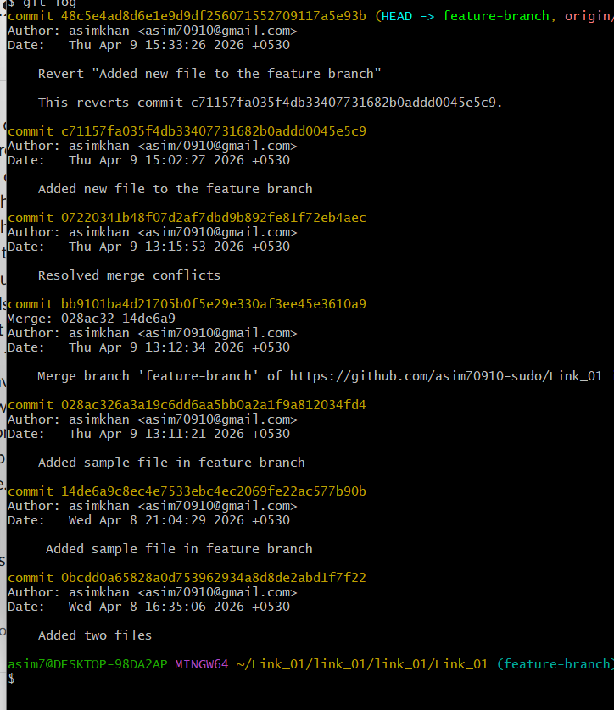

- git log –online
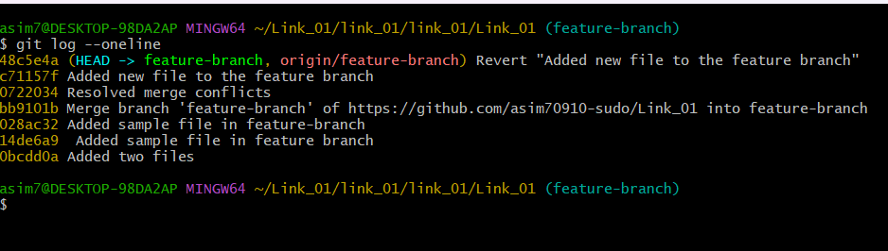

- Git log -p

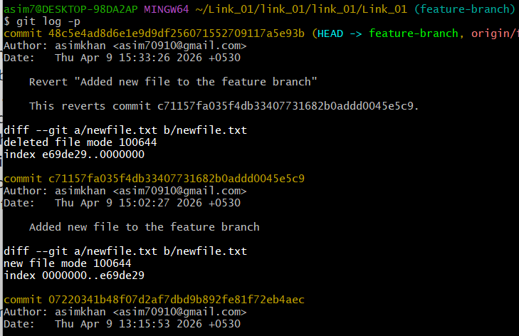

21). Rename the commit message.

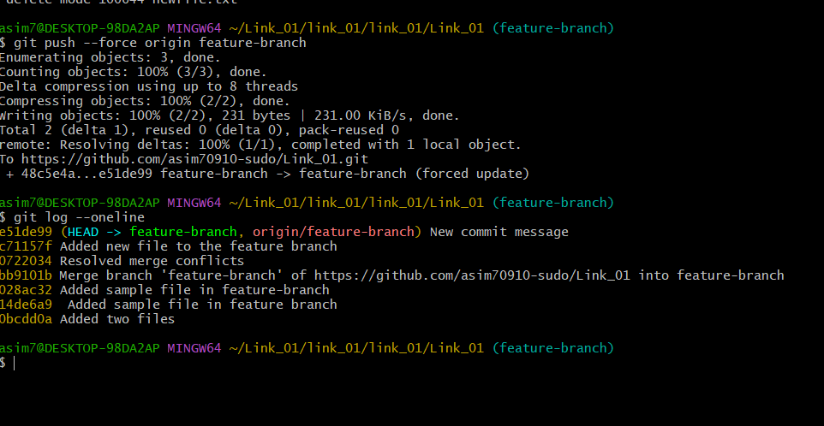

- 22). Merge multiple commits into single commit.

